Name:____________________________________________ Date:________________ Period: _______

Physics 514 Test # 1: Conversions, 1D Motion, Momentum (70 Points) Mr. Werman
Equations/Conversions
14. The Blue car starts at the +3.00 m mark and finishes at the -1.00 m mark over a period of 4s. What was its average velocity? Sketch the motion of the car on a Position vs Time graph (label the axes). (5 Points)

15. Convert 426 $\frac{dip}{tack^{4}}$ to $\frac{dap}{rip^{4}}$ (Note: 1 dip = 6 dop, 1 dop = 8 dap, and 3 tack = 10 rip) (5 Points)

10. Coach Ansel takes his players through a conditioning drill in practice. Starting under the basket at the endline, the player sprints 47 feet to midcourt in 3.5 s, then backpedals 28 ft with a speed of 4 ft/s to a cone at the free throw line, before sprinting to the far endline at a speed of 15 ft/s.
a) What is the player’s total time for the drill? (3 Points)

b) Sketch the Position vs Time and Velocity vs Time Graphs for the player’s motion: (2 Points)

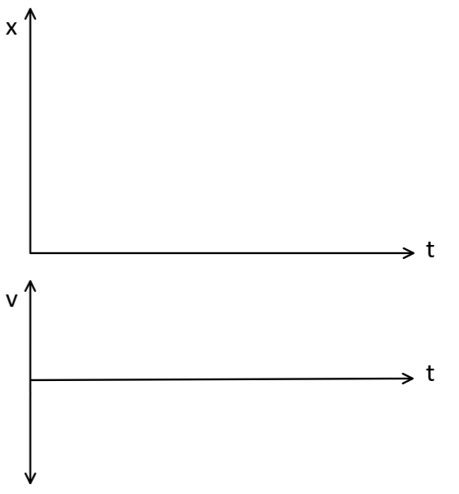

17. A 7.25 kg bowling ball traveling with constant speed hits the pins at the end of an 18.3 m long bowling lane. The bowler hears the sound of the ball hitting the pins 3.50 s after the ball is released from his hands. How much momentum does the ball have when it strikes the pins? (Note: the speed of sound is 340 m/s)
(10 Points)

